
Whitepaper

Futurewei EDA Solution

To be removed for release
V 0.1 | 03/04/21 initial draft

Contents
1 Introduction 2
2 Use Cases and Workload Characterization in EDA 4
2.1 Frontend Design Phase 4
2.2 Backend Design Phase 4
2.3 Summary 4
3 EDA in Enterprise Storage 5
3.1 DELL/EMC® Solution 5
3.1.1 Overview 5
3.1.2 Solution Introduction 6
3.1.3 Metadata 7
3.1.4 Storage Efficiency and Utilization 7
3.1.5 Data Management 7
3.1.6 Scalability 7
3.1.7 Solution Review and Comments 7
3.2 Pure Solution 7
3.3 Netapp® Solution 7
3.4 Other vendors and Trends 7
3.5 Comparison Chart 8
4 EDA in Huawei Storage 9
4.1.1 Overview 9
5 EDA Requirements 9
5.1 Key Requirements 9
5.2 Gaps 9
5.3 Trends for EDA Solutions 10
6 References 10

Introduction
Electronic design automation (or EDA) is referring a series of software and design flows that chip designers use to design and analyze entire semiconductor chips.
Chip designers can't design any IC chip without aids of proper design workflows and EDA tools since there are often billions of components involved in this process.

According to the Electronic System Design Alliance, EDA industry revenue increased 15% in Q3 2020 to $2,953.9 million, compared to $2,567.7 million in Q3 2019, with all categories logging significant gains. The four-quarter moving average, which compares the most recent four quarters to the prior four quarters, rose by 8.3%. The product category showing the strongest growth was IP, with a 25.8% revenue increase. In terms of regions, Asia Pacific reported the best results with a 26.4% growth. The EDA companies tracked by ESD Alliance employed 47,087 people in Q3 2020. [1]

Current EDA workflows are very modular. Generally speaking, it can be broken down into 2 stages as shown in the figure:

- Frontend logic design (Logical design)
Frontend logical design produces standardized design descriptions based on certain languages like Verilog, RTC etc. Those descriptions are compiled into certain logic design descriptions sometimes called netlist files. During this stage, IC design development and logic simulation are involved.

During frontend design, EDA developers draw chip design by compiling source files into a chip model. Developers then verify designs by scheduling and running parallels jobs in large compute environments. It is a iterative development process for developers to refine their designs.

- Back-end logic design (Physical design)
After the frontend phase produces a design that works logically, the physical design phase converts the logical design into an image, verifies it, and prepares it for delivery to a foundry, which manufactures the chip.
Back-end logic design produces fab specific data based on time-sequence design, layout, route design, etc. This process generally involves several simulations like power, heat, logic, timing, pace, routing.

Use Cases and Workload Characterization in EDA
As mentioned in section 1, EDA process generally speaking, can be broken down into frontend and backend design phases. Each phase has fairly different workloads and requirements for storage.

Frontend Design Phase
During frontend code development stage, not a lot of workloads are generated by engineers. However, those files just like software codes are very important and demand ultra-reliable storage features such as Active-Active replications, Snapshot, CDM etc.

The frontend simulation and verification phase does generate very I/O intensive workloads since most of verifications are running in parallel. IC design applications read and compile millions of small source code file to build and simulate a chip design. And considering a storage system typically shall support such large group of developers and engineers, workload is considered massive in term of volumes. The workload can be characterized as large number of small file random reads with burst. Qos and multi-tenancy features shall be quite useful since it is prohibitive for one user to hog all the resources.

At the end of frontend development phase, large files(netlist) are generated and sent to backend phase for further processing.

Backend Design Phase

. For example, a single GDSII file can be 10GB in size. There is going to be several iterations for backend verifications. It is critical for storage system to handle such workloads so that engineers can have enough time to validate chip designs. Any design defects may potentially result in delay of fabrication or a decrease in the yield.

Summary
Generally speaking, EDA application tends to generate large number of files in a single directory. Therefore, the depth of directories and number of files in directories cannot be the limiting factor for storage performance.

EDA process demands high reliability features such as replications, snapshots and backups. Being able to revert back or examine previous design for defects and troubleshooting are critical. Storage shall be able to retain at least up to 1 month of snapshots for an active project and years for released products.

EDA customers tends to run large number of projects in parallel. Storage performance, capacity are in high demand. It is also beneficial to have tiering, Multi-tenancy, Quota and Qos preventing one project hogging too much resources.

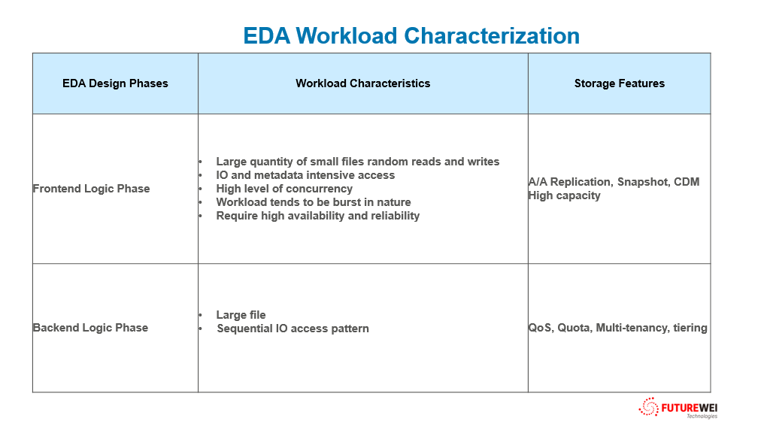

EDA in Enterprise Storage
In this chapter, EDA solutions from various storage companies are elaborated.

DELL/EMC® Solution

Overview
Dell EMC® offers various NAS solutions, from vNAS offered by PowerMax to PowerStore NAS solutions.

In EDA sectors, DELL/EMC® believes performance bottlenecks growing worse at scale. A traditional scale up architecture has several major drawbacks:

- Capacity and performance scalability:
Data migrations to balance storage performance for EDA applications due to single controller’s capability and throughput.

- Storage Silos:
Due to limits of storage controllers in term of throughput and capacity, several separate storage systems have to be deployed to support such kind workloads and use cases. That leads to what we called “storage Silos” – an undesirable consequence due to limitation of scale up storage systems to support scale out workloads and use cases.

- Storage utilization efficiency:
Due to storage silos, a lot of volumes are underutilized while others are oversubscribed. This inefficiency leads not only more costs for customers but longer time to solve the problem(Need data migration to larger capacity systems etc.)

- Complexity of System Management:
Another side effects of scale up storage system is no centralized management for storage systems. But most storage vendors do support across system and DC level storage management software. A center point of management still has its merit.

- Storage Capacity Forecast and Uncertainty:
Up-front purchasing increases customers’ TCO and never proven be much accurate. Capacity expansion generally speaking involves downtime and service disruptions. Data migration is often needed for the purpose of load balancing.

- Performance Hotspots:
EDA workloads involves large files and millions small files read and writes. It can easily become bandwidth and metadata intensive operations. In order to eliminate hotspots found in the systems, scale up system have to add more cores (very difficult and costly upgrades), memories and controllers. It never be guaranteed to be as efficient as scale out systems.

Based on those rationales, DELL/EMC® choose PowerScale® (Previously Isilon® ) as its major offering for EDA customers [2].

Solution Introduction
Dell EMC® offer PowerScale® as one stop shop for the solutions. In order to accommodate different workloads, different type of node configuration can be supported:

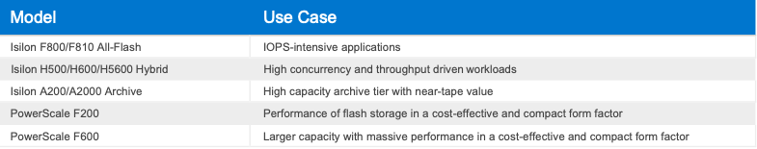

With this flexible combination of node configurations, PowerScale® can claim supporting various dynamic EDA workloads.

Metadata
PowerScale® solution assumes metadata operations account for more than 60% percent of EDA workloads for its customer base. It is debatable if it reflects other EDA customers, but metadata is considering very important performance metrics for EDA applications.

Storage Efficiency and Utilization
DELL/EMC® considers that a typical semiconductor design data set is about 90% of small files and 10% of large files in thousands of project directories. There are about 60% of data is active. There are short term retention combined with long term backup strategy.
DELL/EMC® believes traditional filers are not typically efficient to utilize disk space:
- Smaller raid protection or EC(5+1 or 4+2, etc)
- Snapshot volume provision or reserved space
- File system overhead(log, metadata, etc)
- Disk spare etc
In practice, a storage system may have up to 50% total capacity just for overhead.

PowerScale® cluster claims running at 70% to 80% storage efficiency for semiconductor design data. It is achieved by using wider EC and efficient metadata management.

Data Management
PowerScale® can seamlessly scale cluster to match ever-increasing storage requirements for semiconductor design project data. PowerScale® cluster solves many common data management problems for semiconductor companies by providing capabilities that traditional storage system lacks.
- Global namespace, single volume no storage silos.
- Seamless capability
- Efficient data management
  - Data evenly distributed to remove hotspot
  - Different disk tiers in one storage pool and auto tiering

Scalability
PowerScale® can scale up to 255 nodes with huge capacity for a single FS.

Solution Review and Comments
EMC® /DELL believes storage scalability, efficiency and capability of processing metadata are keys for EDA solution. Traditional filers may not provide all those. However, in reality, the requirements of capacity and scalability for EDA software are not on the level of SDS cloud. Enterprise storage with fairly good scalability is better choice. Enterprise NAS offers far more superior enterprise class features which are lacking in PowerScale® due to architecture limitation and focuses. (For example, A/A replication, etc)

PURE Solution

Solution Introduction

Pure EDA solution is also nothing new. The assumption for its solution is high concurrency, high bandwidth and low latency. They are generally common requirements for EDA and high-performance NAS arrays.
The high-performance requirements are mainly derived from verification process. The growing complexity of chip design has increased over verification process in term of complexity and amount of work. However, customers still push for same timeframe for delivery. High intensive metadata operations, high bandwidth large IO and random small IOs are saturating NAS storage systems.
Pure Storage® provides it FlashBlade® array as its EDA offering.

Namespace Partitioning
Pure Storage® believes file system ownership is inherited problem for scale. It is a valid point. Filesystem ownership introduces more problem than benefits. Load balancing and HA are major problems for file system ownership.

Distributed Locking
This is directly targeting products such as Isilon® . An active/active file system cluster architecture does require so called “distributed” lock scheme. It is one of reasons why Isilon® require high performance network (InfiniBand). However, other storage vendors have other ways to avoid extensive distributed locking(directory ownship, etc). This shall not be considered as showstopper for EDA

Dedicated Metadata Server
Again, Pure wants to use this to target certain vendors products. Most of modern NAS vendor provide active/active NAS cluster architecture. Therefore, eliminate the need of dedicated metadata server. This is still a valid point for EDA since EDA workload does involve heave metadata operations. Single server may not be able to handle such workloads.

Netapp® Solution
Netapp® approach and solution for EDA have drastically changed in the last few years. Netapp® filers have been widely used by EDA companies. It is still considered by EDA customers as top NAS suppliers.

In recent years, as companies refocus their IT infrastructure to leverage more on cloud infrastructure, Netapp® believes their EDA customers eventually will make that moves too.

Netapp® solutions revolves around their key initiative – Cloud Volume ONTAP® .

Netapp® Cloud Volume ONTAP® is positioning very well for these efforts:

Agility
Cloud Volume ONTAP® makes cloud bursting easier to manage. Customer does not have to worry about data mobility. Cloud Volume ONTAP® does that for customer.

Data Caching
FlexCache features also enables quick replication between on-prem and cloud.

Performance
Cloud Volume ONTAP® use internal NVME drive as cache to eliminate cloud storage performance problem.

Features
These features combine to offer benefits that can significantly optimize and shorten EDAs’ chip emulation lifecycle. With Cloud Volumes ONTAP® :
- Storage resources are available on-demand.
- Data collaboration across groups, locations, and hybrid architecture.
- Complex infrastructure, data sets, and access permissions are mirrored in the cloud.
- Data is protected with Netapp® Snapshot™ technology and enterprise data security.
- Efficient and continuous DR replications via SnapMirror®.

Comparison
While traditional storage vendors have been supporting EDA scenarios for quite long, most of vendors focus on bandwidth, high performance and high reliable enterprise NAS storage products. We consider there are not significantly differentiation on all those filers. Performance differentiation is not enough as deal breaker.
However, we believe Netapp® Cloud Volume Solution offer a significant upgrade to other vendors approach as cloud-ability and containerization are the new requirements from EDA customers in the future.

Recently, Pure Storage® acquired Portworx as their cloud native storage solution. Portworx provides Pure Storage® similar capability as Cloud Volume on cloud native application front(Container).

HPE also acquired Zerto to expand its edge to cloud platform. It further reinforces this view.

EDA New Trends

Cloud-ability
Like every software/IT vendors, EDA vendors are facing more pressures internally and externally to move their workload to cloud for elasticity, easy of management and lower TCO. As more non-EDA IT have cloud initiative, CIOs are asking EDA to have to have a Cloud strategy.
Previously due to security concerns, EDA is shy from cloud implementation. However, since most of other company critical IT assets are into cloud, such as Payroll, Finance, there are no reason EDA shall be held back.

EDA process usually involve several stages which require compute intensive operations and more resource. The growing complexity of verification has also drive the cloud demands across the board. Verification in general, be it simulation, emulation or characterization. These are very compute intensive. A lot of time EDA asks peak capacity and peak compute. Now the mindset is changing to a hybrid environment not just on-prem or cloud. Hybrid provides flexibility and elasticity.

Now, cloud and hybrid cloud provide elasticity and reduce complexity. How can storage system to catch up those?
- One of the major trends are on-prem storage systems with data mobility – a hybrid cloud storage solution.
- Another trend is to provide Pay-U model for EDA customers so that they can enjoy most of cloud features without scarifying any on prem advantages.

Containerization
This is related to cloud-ability. EDA usually runs on Linux and windows. However, Linux has been the major operating system for EDA tools. Installing and running EDA tools to adoption of Linux can be a hassle. Linux packaging is a good tool to manage complexity for most of software. However, none of EDA vendors use that (of course, those are paid software!). Containerization is a better way for EDA vendors to deliver such capabilities.

EDA process traditionally has a lot of parallelizable jobs which can be run simultaneously. With the focus on reducing initial products development cycles, EDA processes are looking increasingly for ways to maximizing parallelism and micro-services model to achieve reduction of TTM.

Containerization is one way to achieve that. Combining cloud-ability, it is naturally for EDA process to run entirely on container clusters (Kubernetes). By saying that, support of Kubernetes storage (storage CSI) and other enterprise class storage features on top Kubernetes (Such DR, replication, tiering etc) are increasing important for EDA process.

EDA SasS
Bigger EDA software companies are offering SasS platform. For example, Cadence offers Cadence cloud.
The driving force for this have 2 sides reasons:
- The need for EDA software companies to move to subscription based SasS
- Infrastructure cost and manageability for EDA customers to leverage public cloud services.

The benefits to move to hybrid cloud model has significant benefits for EDA customers. They can fit their EDA business logic easier for a cloud bursting platform. EDA customers also do not have to worry about optimization, configuration and management of complex EDA environments. They are all managed by EDA SasS. With hybrid model, they can even leverage pay as you go and save significant acquisition cost for infrastructure.

References

[1] | [Online]. Available: https://www10.edacafe.com/blogs/editorial/2021/01/11/eda-q3-figures-achronix-to-list-on-nasdaq-automotive-chip-shortage-smic-added-to-entity-list-ai-updates/.

